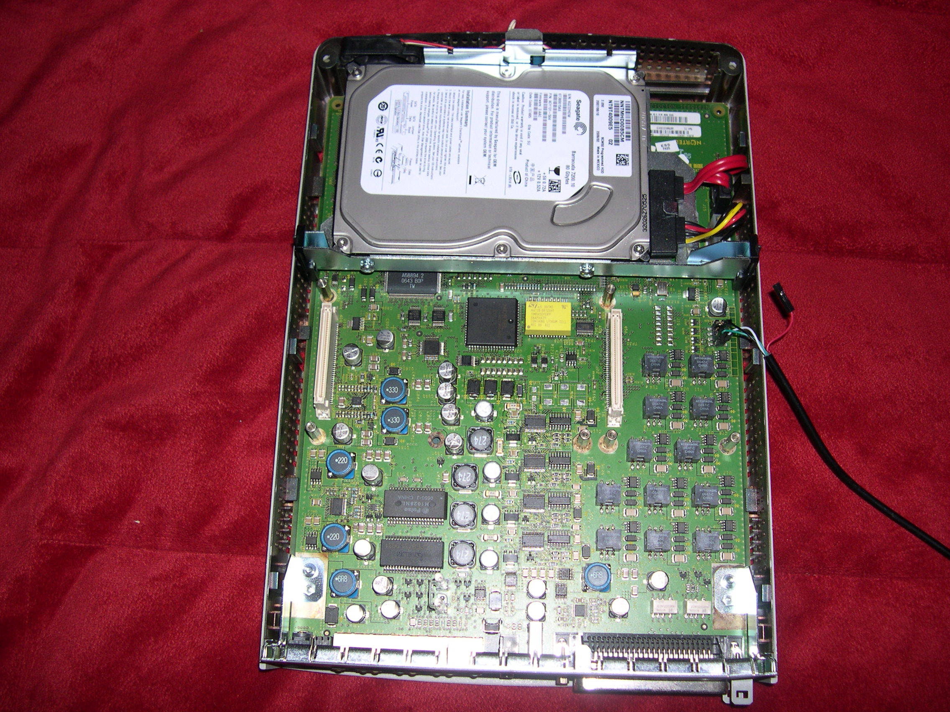
With the serial cable attached and the 2 daughterboards removed.

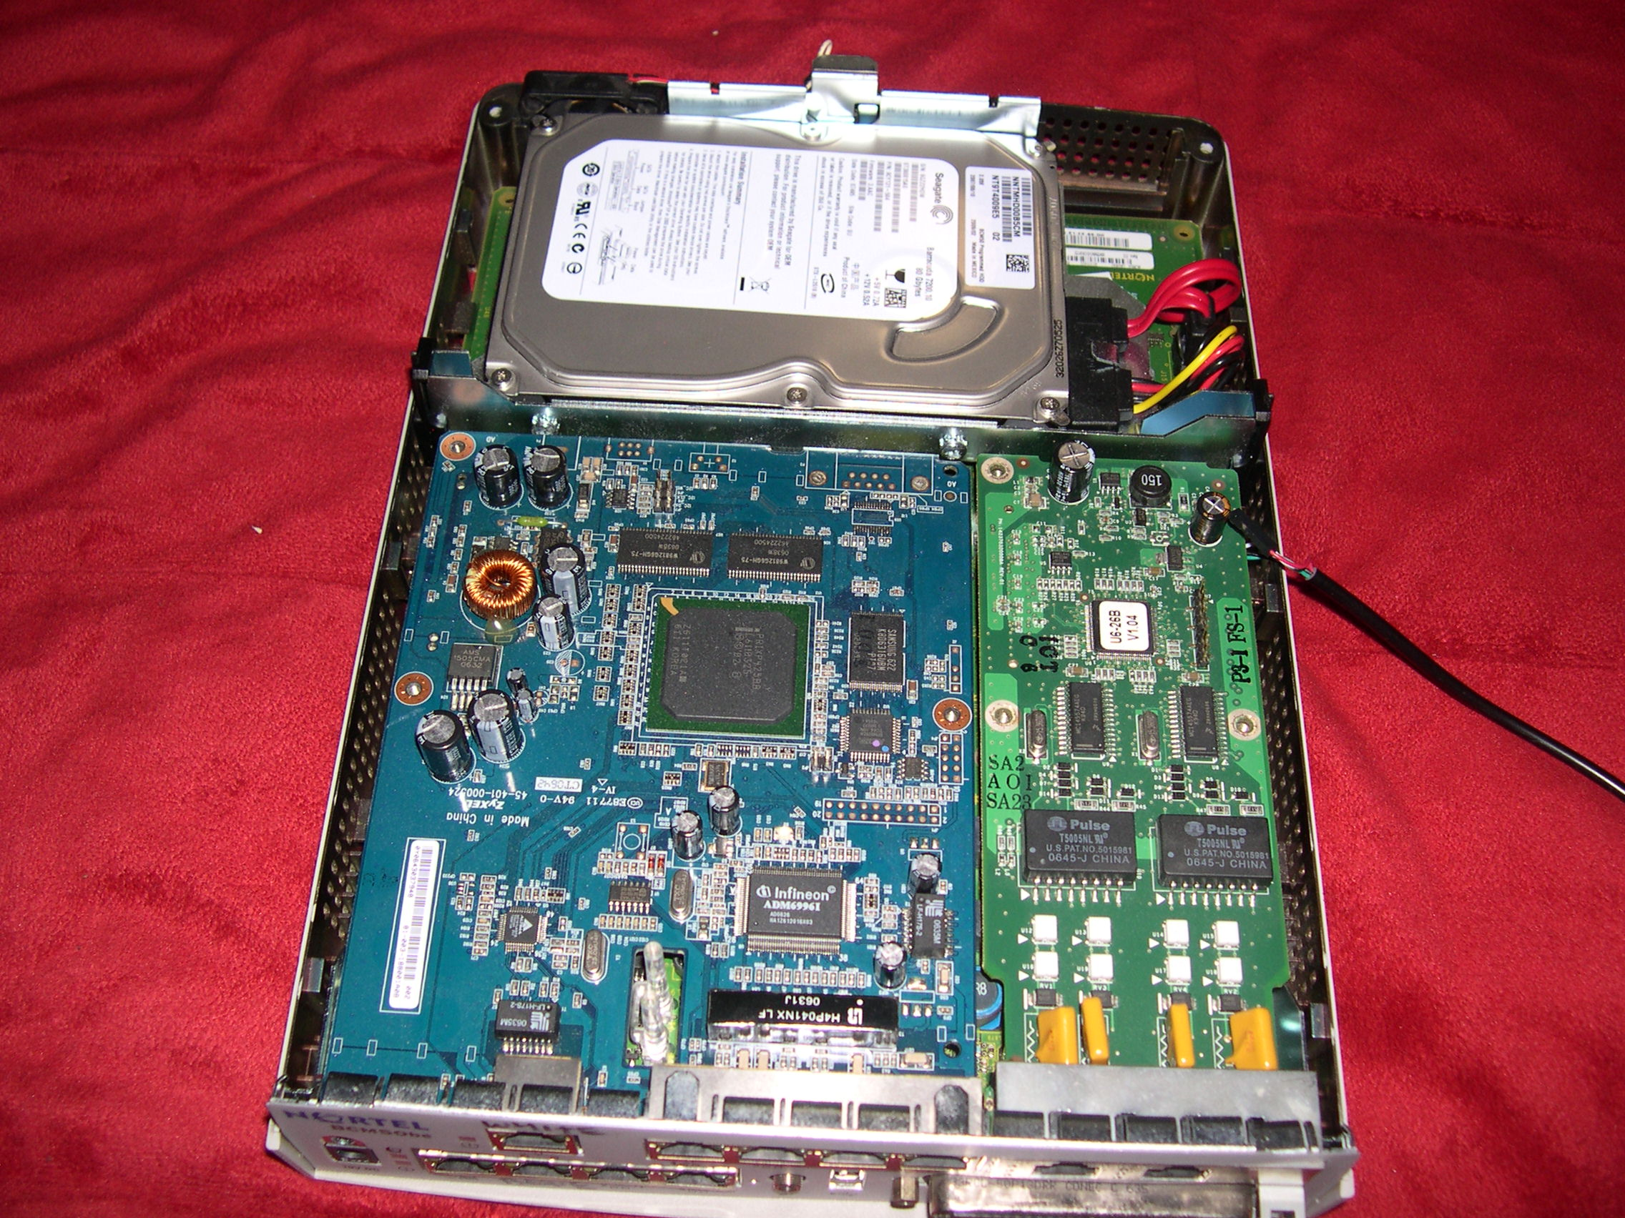
With the daughterboards attached. Router on the left, BRI on the right.

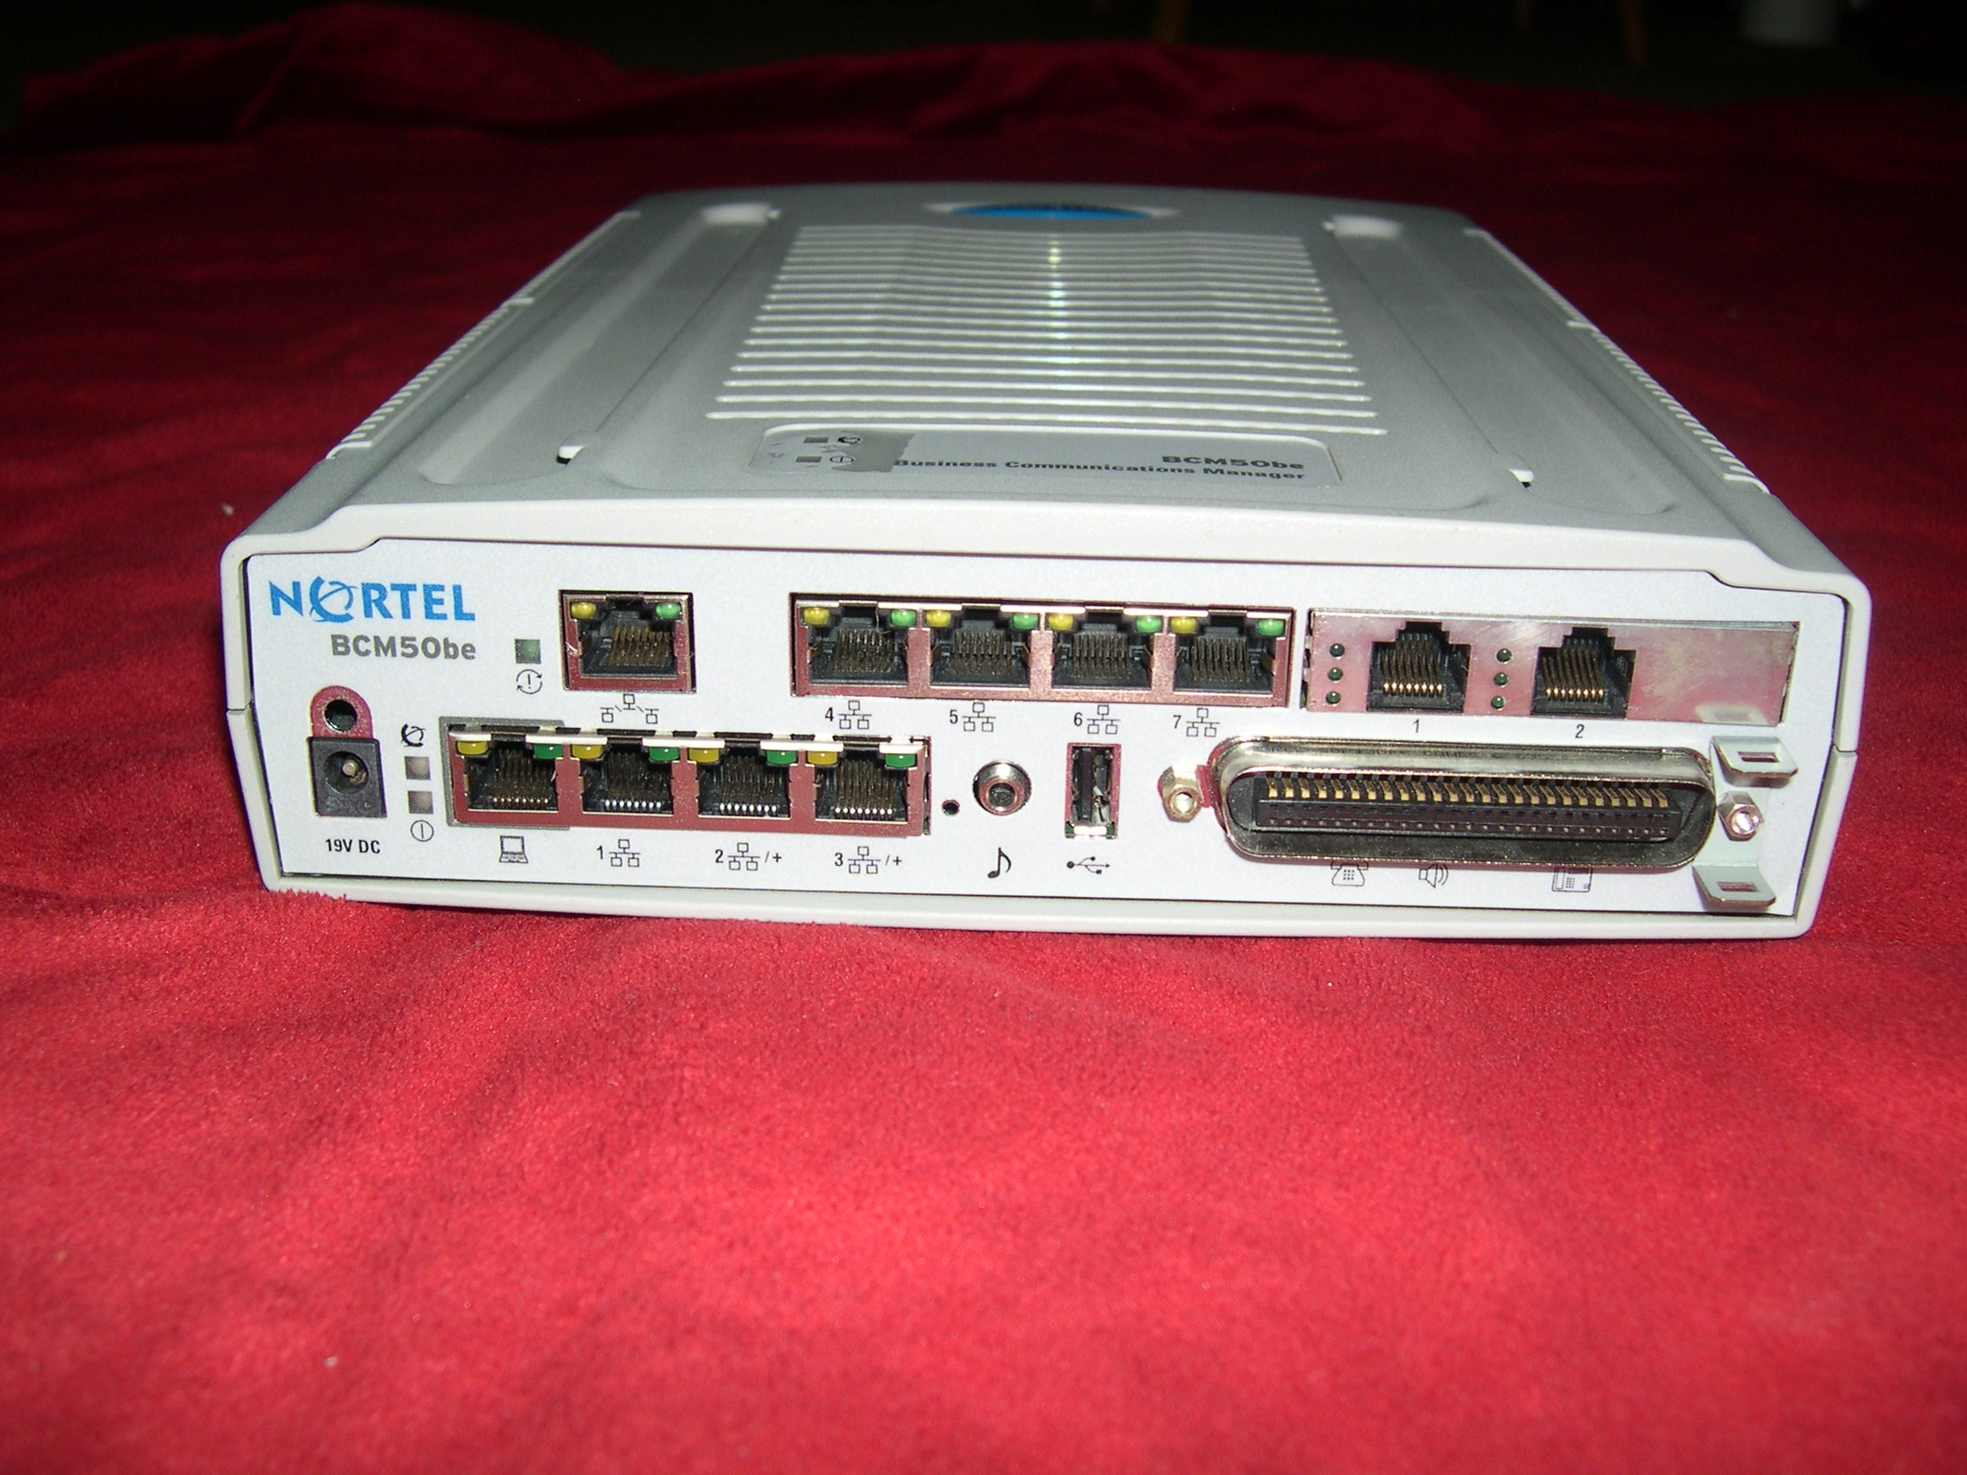
Front view.

